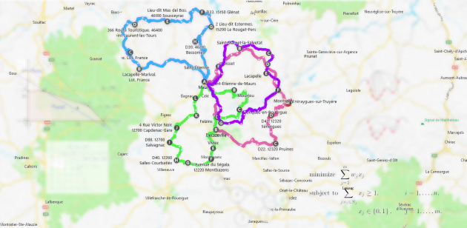

Algorithmics and combinatorial optimization
Keywords

- Routes management
- Smart Multimodal Mobility
- Time slots
- Resource management optimization
- Algorithmic optimization
- Transport logistics problems
- Road work maintenance
- Operation research
- Financial schemes
- Statistical study
- Large instances
- Item footprint
- Traffic flow
- Neighborhood based method
- Industrial application
- Constraints (OR)
- PEP recommendations
- Algorithmic design
- Formal modelling
- Notebook (Jupyter ?)
- Data story-telling aspect
- Scalability
- Mass-produced
- Objectives function
- NP-hard

Context

Meriem’s :
CesiCDP is responding to ADEME’s mobility call by optimizing delivery routes with algorithms that minimize travel time. The study explores constraints like time slots, truck capacity, and traffic variation to ensure realistic solutions and secure new markets.

Manav’s :
CesiCDP is developing an optimization algorithm for city delivery routing, addressing ADEME's call for innovative transport solutions. The project aims to minimize travel time while considering traffic constraints, utilizing Operations Research techniques to solve this NP-hard problem and secure funding for future mobility solutions.

Constraints (from Moodle)

Basic :
- Selecting the model and code in Python capable of solving large instances (several thousand cities)
- A statistical study regarding the algorithm’s experimental performance

Additional constraints :
Here is a (non-comprehensive) list of constraints that could be incorporated into your study scope. For some of them, advanced versions are also provided. Please note that implementing one constraint and any of its advanced versions is the same as implementing two constraints.
- Delivery time slot for each item
  - No deliveries allowed beyond the time slot
  - Waiting on site for the time slot to open is a possibility
- k trucks simultaneously available to make deliveries. The route calculation will have to include the allocation of items (and therefore the delivery points) to the different trucks available, and instead of minimising the total time, one should minimize the date when the last truck returns to base.
  - Truck capacity (2 or 3 dimensions) and item footprint
  - Some items can only be delivered by certain trucks
- Each item has a specific collection point
- The travel time of an edge varies over time (which is equivalent to varying its length), to represent the variation in traffic flow
These constraints can be divided into two categories:
- Constraints that do not change the space for solutions, only their values. For example, by taking into account time slots where waiting is required (if the truck is ahead of schedule). In the case of a neighbourhood-based method, the neighbours of a solution will not be changed by incorporating this constraint, only the costs will be different
- Constraints that change the space for solutions. For example, some items that require a specific type of truck for being delivered. Adding this constraint will render some solutions invalid, and consequently limit the space for solutions.
Other constraints can be addressed, if this is justified by an industrial application (not necessarily resulting from the current context).

Problem statement

Find the algorithm to get the optimal routes subject to certain constraints.

Hypothesis

- Use theory of graphs
- Queue certain routes for trafics
- Finding objectives functions
- Find the best algorithms
- Analyze using statistics / Mathematical functions
- Use Jupyter Notebook
- Propose an experimental design to compare the different meta-heuristic

Deliverable

First deliverable (17/10) :
- Formal modelling
- Algorithmic design and implementation

Second deliverable (15/11) :
- Experimental study
- Presentation of the work done to your team (in English) before submitting the deliverables to ADEME

